LEARN TO RIDE

High-quality **Western and English** rides lessoning, focusing on safety and including instruction on horse care, saddling a horse, and other aspects of horsemanship.

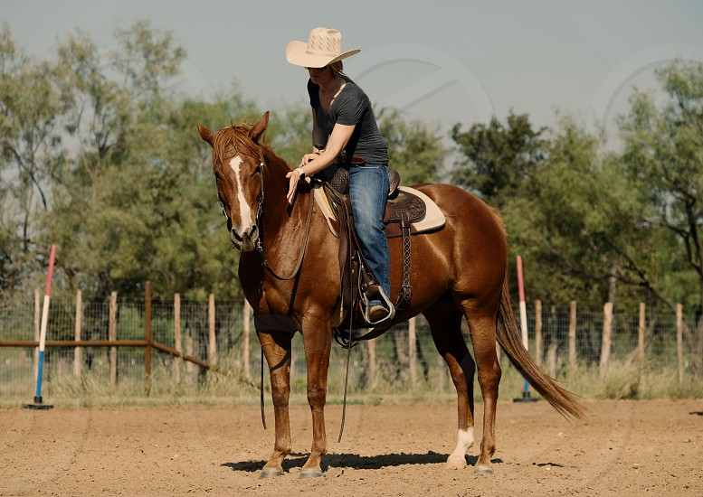

* Novice to advanced instructions for children and adults
* Indoor and outdoor arenas
* $40 per hour for private lessons, $25 for group lessons

# CALL TRI-VALLEY STABLES AT 555-2030 TODAY!